**Lab Practical #06:**

Study the application layer protocol DNS, DHCP, FTP.

**Practical Assignment #06:**

1. **Implement the application layer protocol DNS, DHCP, and FTP. Also check connectivity between them using ping command or PDU utility.**
2. **DNS :-**

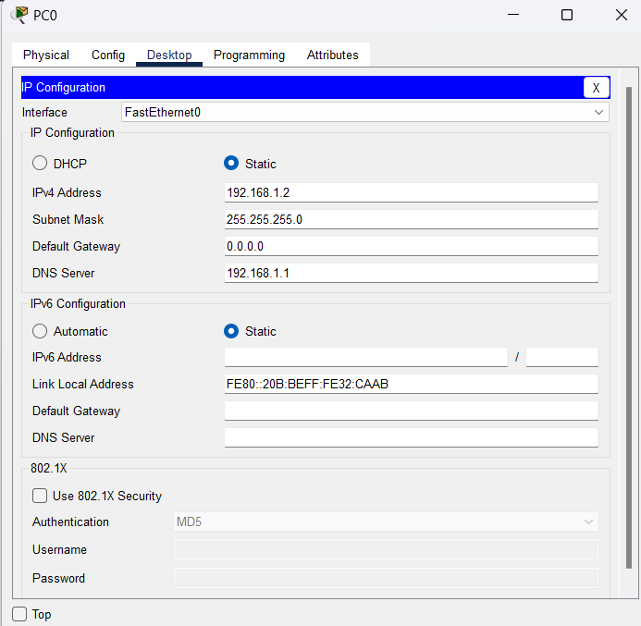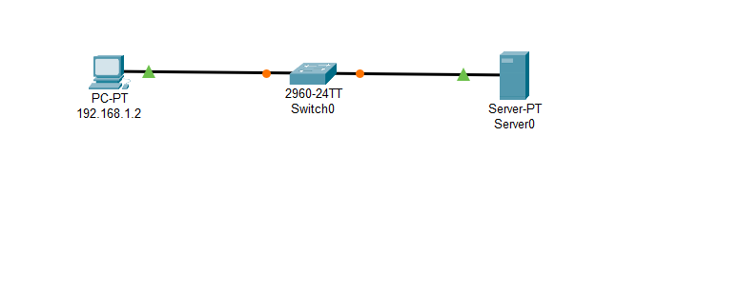

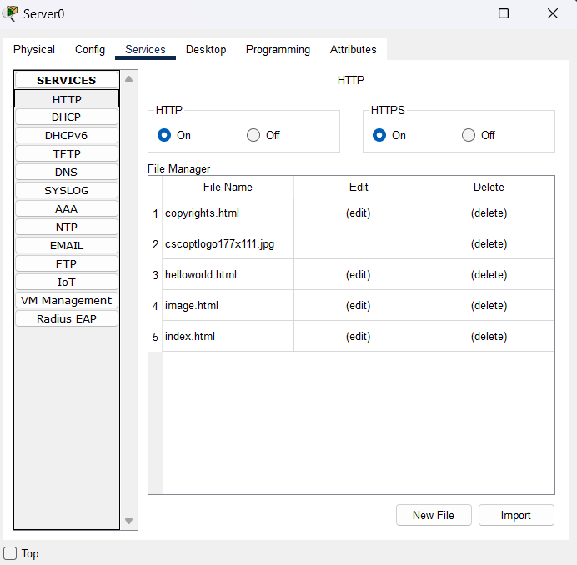

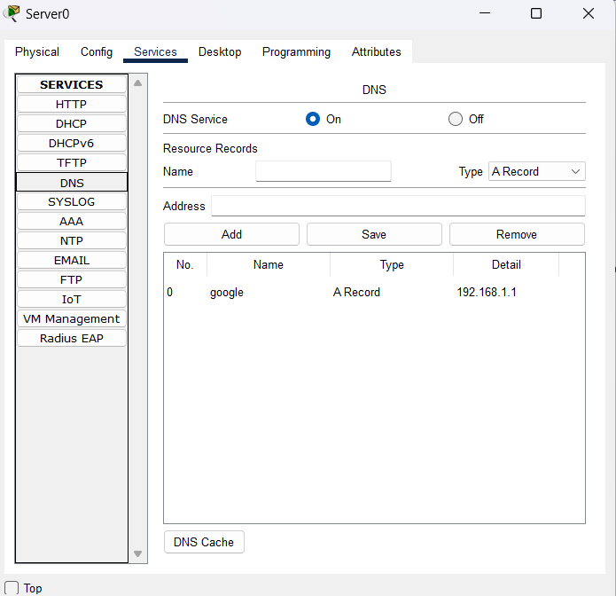

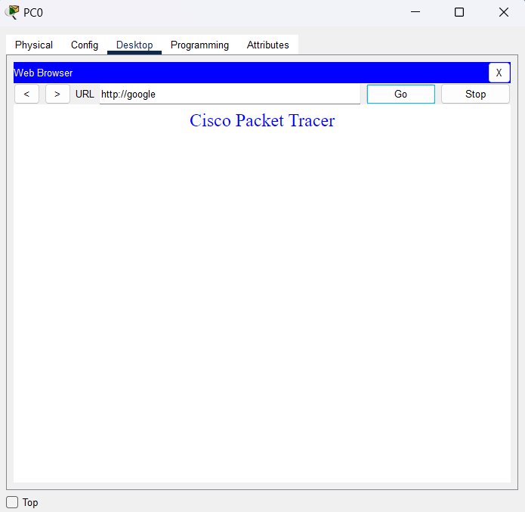

**Steps :-**

* Add One PC , One Switch, One Server .
* Connect the devices.
* Assign an IP address(192.168.1.1) in server.
* On Http and Https on button in Http in services.
* Turn on the DNS Service by clicking the On button.
* Add a DNS record like Name: google , Address: 192.168.1.1
* Assign an IP address(192.168.1.2), subnet mask(255.255.255.0), and DNS server(192.168.1.1) address.
* In PC0, go to the Desktop tab.
* Open the Web Browser.
* Enter http://google in the URL field and click Go.
* The web browser should attempt to connect to 192.168.1.1.

1. **Dhcp:-**

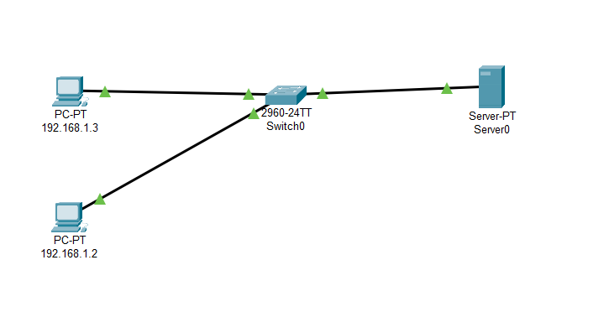

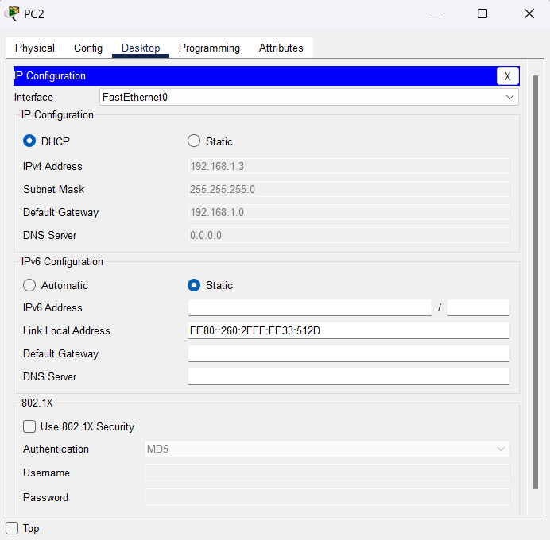

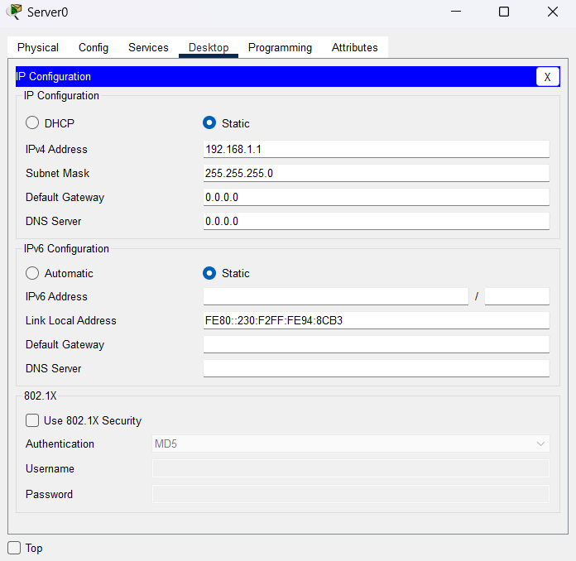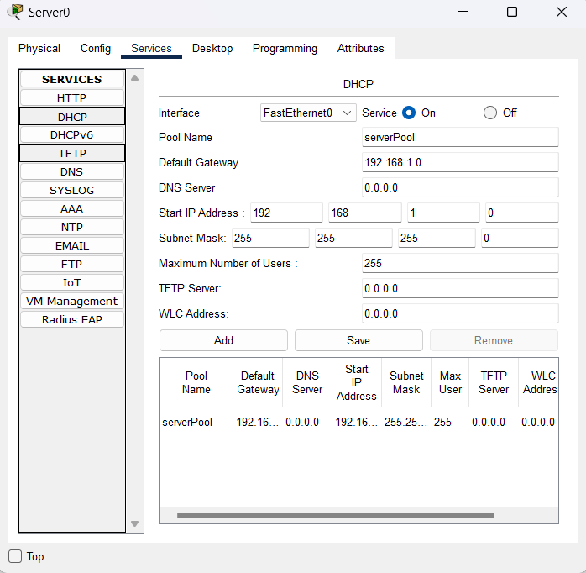

**Steps :-**

* Add Two PC , One Switch, One Server .
* Connect the devices.
* Turn on the DHCP Service by clicking the On button.
* Pool Name: serverPool , Default Gateway: 192.168.1.1 , DNS Server: 192.168.1.1 ,

Start IP Address: 192.168.1.2, Subnet Mask: 255.255.255.0.

* Click Add to save the DHCP pool configuration.
* Turn on the DHCP desktop and configure IPaddress to static.
* Configure the PCs , Set the IP configuration to DHCP.

1. **FTP :-**

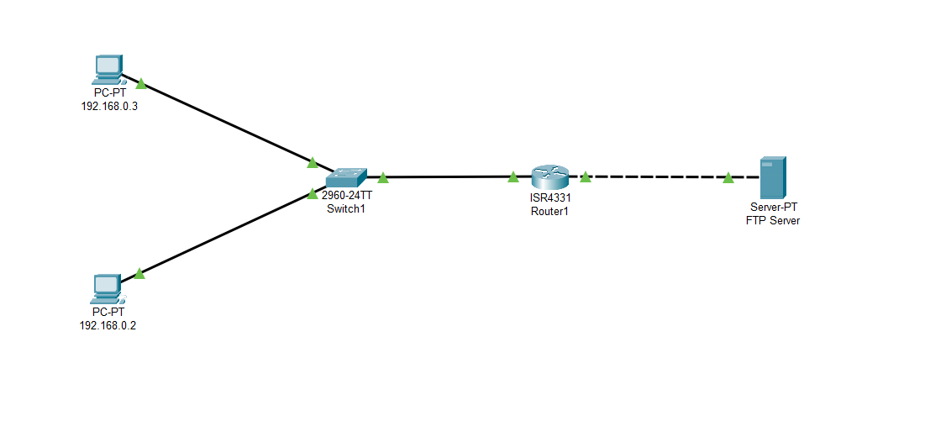

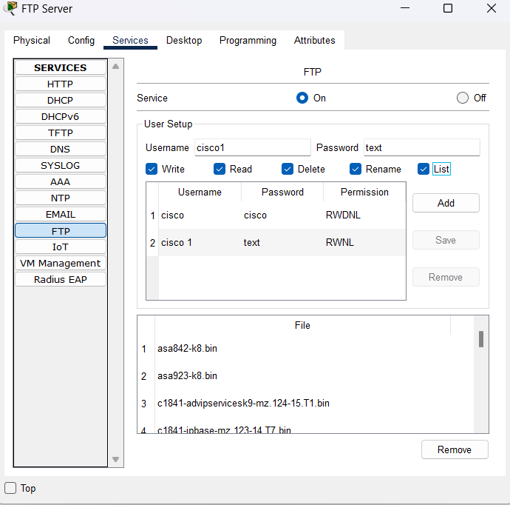

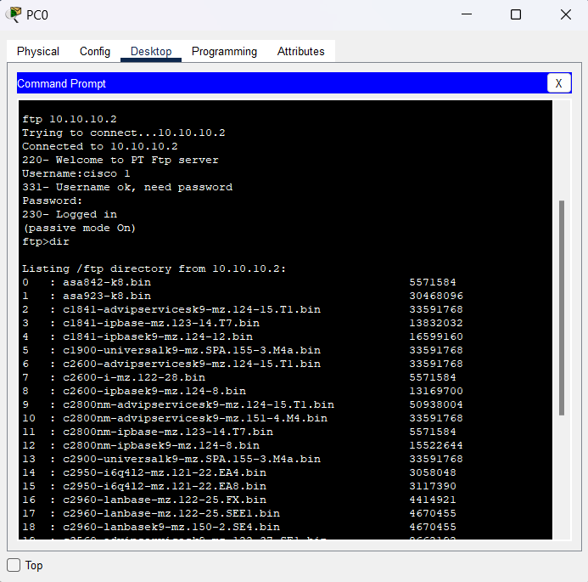

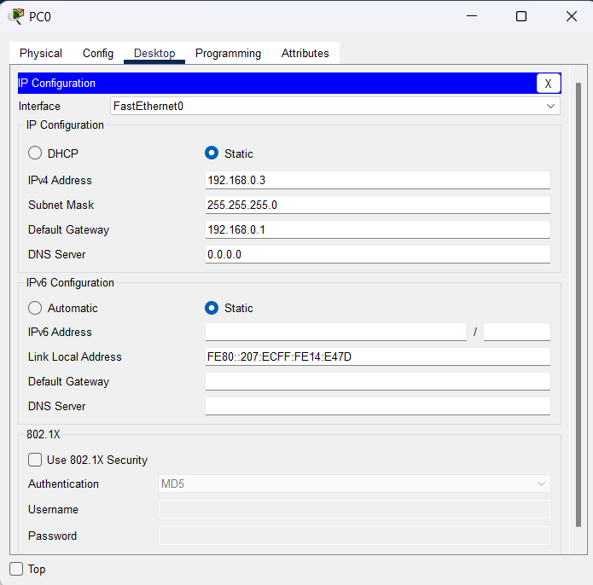

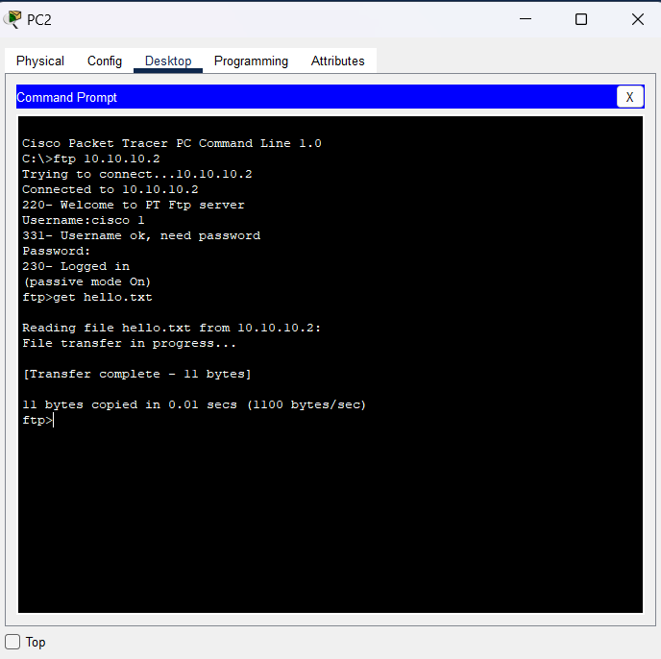

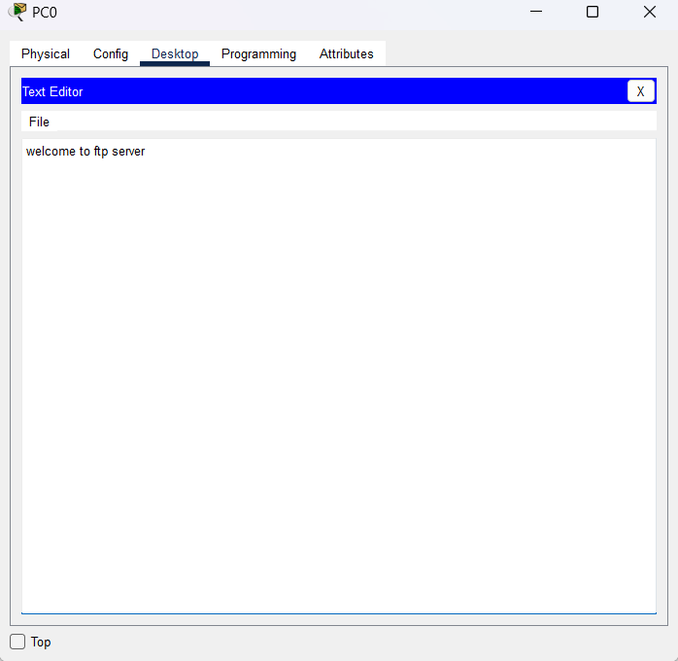

**Steps :-**

* Add Two PC ,One Switch, One Router,One Server .
* Connect the devices.
* Assign IPaddress (10.10.10.2) in sever.
* Turn on the FTP Service by clicking the On button.
* Configure username(cisco 1) and password (text) and allow permission and click add button.
* Now one text file(hello.txt) created in text editor in desktop .
* Now open command prompt in desktop in server.
* Write ftp IPaddress (10.10.10.2) after enter username and password .
* After login write dir to check filename.
* Assign ipaddress(192.168.0.3) , subnetmask(255.255.255.0), default gateway(192.168.0.1) in client.
* Now open command prompt in desktop in client.
* Write ftp IPaddress after enter username and password .
* Now write get textfilename.